C Value = 1

Gamma = 0.0001

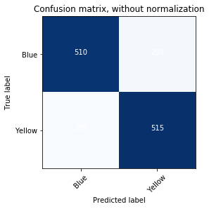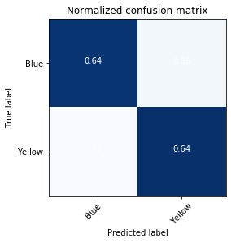

sensitivity = 0.64375

specificity = 0.6375

precision = 0.639751552795031

recall = 0.64375

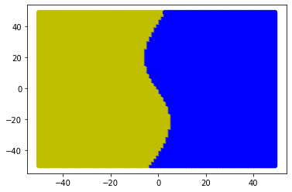

C Value = 1

Gamma = 0.001

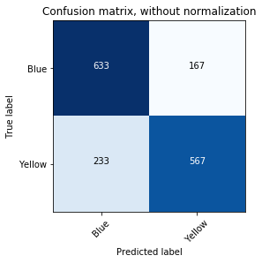 

sensitivity = 0.70875

specificity = 0.79125

precision = 0.7724795640326976

recall = 0.70875

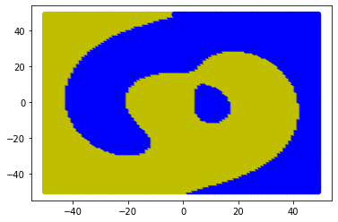

C Value = 1

Gamma = 0.01

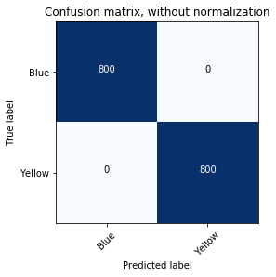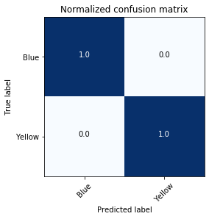

sensitivity = 1.0

specificity = 1.0

precision = 1.0

recall = 1.0

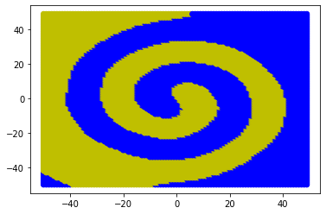

C Value = 1

Gamma = 0.1

 

sensitivity = 1.0

specificity = 1.0

precision = 1.0

recall = 1.0

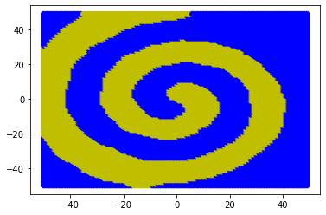

C Value = 1

Gamma = 1

 

sensitivity = 1.0

specificity = 1.0

precision = 1.0

recall = 1.0

